**Lecture Note for Numerical Analysis (11) Interpolation**

1. **Regression and Interpolation (Curve Fitting)**

* Given n data points : 
* Regression: find a curve fitting best to the points 
* Interpolation: find a curve fitting best to and passing the points 

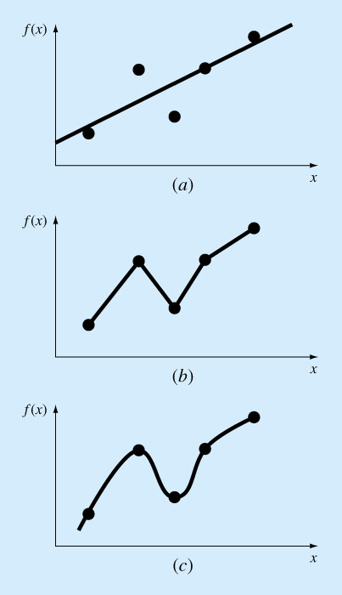

1. linear regression (b) linear interpolation (c) nonlinear interpolation
2. **Basic concept of the polynomial interpolation**

* General form



There should be (m+1)-independent points to determine coefficients  such as





* Various polynomial interpolations

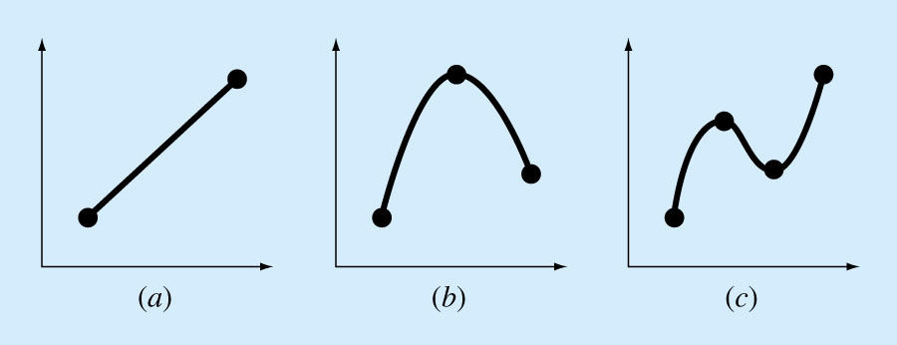

1. Linear interpolation(m=1) (b) quadratic interpolation(m=2) (c) cubic interpolation(m=3)

  

1. **Newton’s Interpolating Polynomial** 
   1. **General form**

Data :

 (1)

Basic form of the Newton’s Interpolating Polynomial

 (2)



* 1. **Computation of the polynomial coefficients of the Newton’s Interpolating**

With the data 

(3)

Therefore, the coefficients can be computed by the following sequential process as

 (4)

* 1. **Another form of the polynomial coefficients of the Newton’s Interpolating: Divided Difference Formula**

**(a) Linear interpolation**

* Given data: 
* Interpolation function: 
* Constraints: 🡪
* Calculation of 

🡪 🡪 

**(b) Quadratic interpolation**

* Given data: 
* Constraints: 
* Interpolation function(m=2):
* Calculation of 

🡪 

 

**(c) nth order Polynomial interpolation: Divided-Difference Interpolation Formula**

In general, if we define the following divided difference formula,

0th order: 

1st order: 

2nd order: 

…….

nth order: 

nth order polynomial interpolation function can be defined as

 (5)

* 1. **Derivation of Divided Difference Formula using Eq (4)**



1. **Lagrange Interpolating Polynomial**

* Exercises

1. Find a 2nd order polynomial  satisfying the following condition
   1. Passing points given: 

Answer🡪 

* 1. Passing points given: 

Answer🡪 

* 1. Passing points given: 

Answer🡪 

1. Find a 2nd order polynomial  passing points of 

Answer🡪 

Proof)



which passes three given points 

1. General Lagrange interpolating function satisfies 



Where the Dirac delta function satisfies

* Definition of n-th order Lagrange polynomial and its property



For 

In case n=3





The Dirac delta function  is defined as 





* Interpolation for the given data 



1. **Spline Interpolation (Spline means a thin flexible strip to draw smooth curves in drafting).**

* Definition of Spline interpolation function: Local polynomial interpolation

 ()

with the given (n+1)-data points



(Example for quadratic spline (n=2)

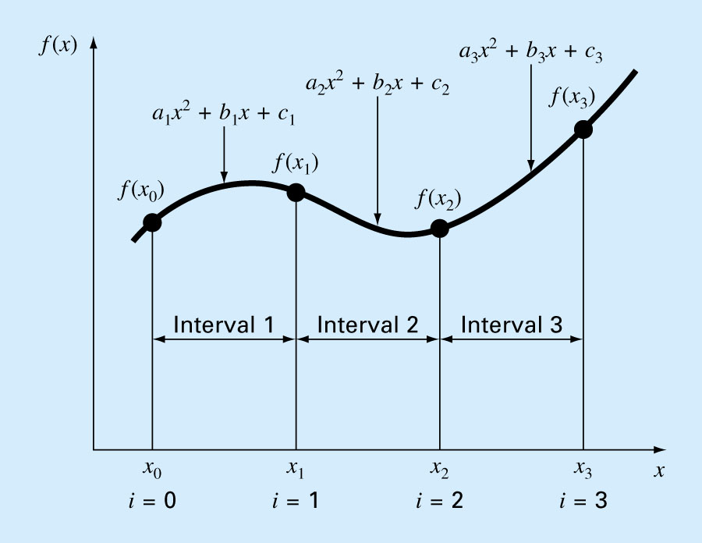







(4-1) Linear Spline



🡪 Unkown 2n ( n for aj , n for bj ) with (n+1) data point.

🡪 (n-1) additional relations are required: continuity conditions at each point 



Linear System to get aj , n for bj

 🡪 



(4-2) Quadratic Spline



🡪 Unknown 3n ( n for aj , n for bj , n for cj): 3n conditions are required

(a) (n+1) given data points.



(b) (n-1)-continuity conditions at each point



(c) (n-1)-continuity conditions for 1st derivatives at each point

 🡪

(d) 1-smooth condition at

**In summary**





If the pivoting is applied,



(4-3) Cubic Spline



🡪 Unknown 4n ( n for aj , n for bj , n for cj, n for dj): 4n conditions are required

(a) (n+1) given data points.



(b) (n-1)-continuity conditions at each point



(c) (n-1)-continuity conditions for 1st derivatives at each point

 🡪

(d) (n-1)-continuity conditions for 2nd derivatives at each point

 🡪

(e) 1-smooth condition at

(f) 1-smooth condition at